CSA0501-DATABASE MANAGEMENT SYSTEMS
LAB EXPERIMENTS DATE:26/08/2026
Ex.No: 19-TRIGGER FLIGHT_RESERVATION_SYSTEM
Aim:
To implement trigger in MySQL.
Description:
A trigger or database trigger is a stored program executed automatically to respond to a specific event such as INSERT, UPDATE or DELETE occurring in a table.
Syntax – Create Trigger
CREATE TRIGGER trigger_name
trigger_time trigger_event
ON table_name
FOR EACH ROW
BEGIN
...
END;
Program 1:
Create a trigger in MySQL to log the changes of the Passenger table with fields Passenger_ID, Passenger_Name and Email. Also create a new table named PASSENGER_AUDIT to keep the changes of the Passenger table. Create a BEFORE UPDATE trigger that is invoked before a change is made to the Passenger table.
SOLUTION:
USE Flight_Reservation;
CREATE TABLE IF NOT EXISTS PASSENGER_AUDIT (
Audit_ID INT AUTO_INCREMENT PRIMARY KEY,
Passenger_ID INT,
Passenger_Name VARCHAR(50),
Email VARCHAR(100),
Action_Type VARCHAR(20),
Action_Time TIMESTAMP DEFAULT CURRENT_TIMESTAMP
);
DELIMITER $$
DROP TRIGGER IF EXISTS before_passenger_update$$
CREATE TRIGGER before_passenger_update
BEFORE UPDATE ON Passenger
FOR EACH ROW
BEGIN
INSERT INTO PASSENGER_AUDIT
(Passenger_ID, Passenger_Name, Email, Action_Type)
VALUES
(OLD.Passenger_ID, OLD.Passenger_Name, OLD.Email, 'BEFORE UPDATE');
END$$
DELIMITER ;
UPDATE Passenger
SET Passenger_Name = 'Rahul Kumar'
WHERE Passenger_ID = 101;
SELECT * FROM PASSENGER_AUDIT;
OUTPUT:
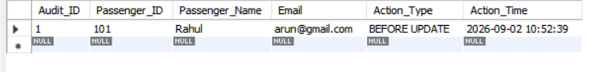

RESULT:
Thus the trigger is executed successfully.

